# Reference for Home Page

[Meeting Minutes with Voice America - Planet Classroom](https://docs.google.com/document/d/1tC2ClJ7PUN-w4wCfows7FCcTGCNDBYZptBwBoQdQAZY/edit?usp=sharing)

(All examples for content suggestions are from Meeting Minutes with Voice America)

# Goals

Create a quick immersive experience

Nail down Planet Classroom with simple effective design

Inspire new visitors to invest in Planet Classroom’s vision

# Sample Outline

*NAVIGATION - Header*

* Company Logo “Planet Classroom” (Far left of Header)
* Company Slogan “Reimagine Learning” (Middle of header)
* Menu Icon (Far right of header)
* Should be provided on every page for the quickest access to all content

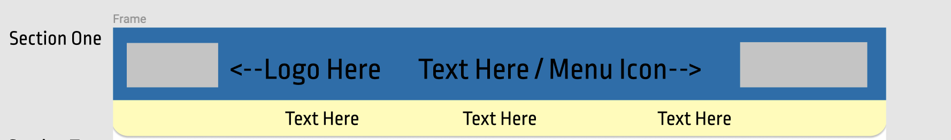

* Links at the bottom should provide quick access to the websites most valuable sections
* Exclusive to only homepage
* “Text Here” next to Menu Icon is referring to company slogan that will go in between website logo and menu icon

________________________________________________________________

*SECTION 1 – PART 1 (Introduction)*

ARTICLE 1

* Will contain quick video related to the company, combined mostly with a call to action to

Inspire first time viewers to join our mission. We want to make the opening pitch

About our vision for the website with this video

* + Create a captivating story to attract new supporters
  + Quick text such as “Reimagine Learning”, “It’s a Movement”, and “Never Stop Learning” can fade in and out beneath the video

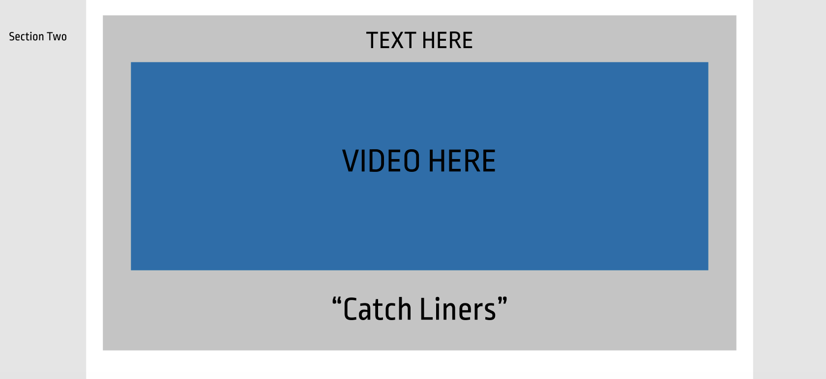

________________________________________________________________

*SECTION 1 – PART 2 (News/Stories)*

ARTICLE 2

* Section 2 will contain information regarding news and challenges
* Panel 1 should have an image with text “NEWS” hovering over it
* Panel 2 contains Planet Classrooms top news. Will be organized in grid like fashion
* Panel 3 contains Planet Classrooms top three stories

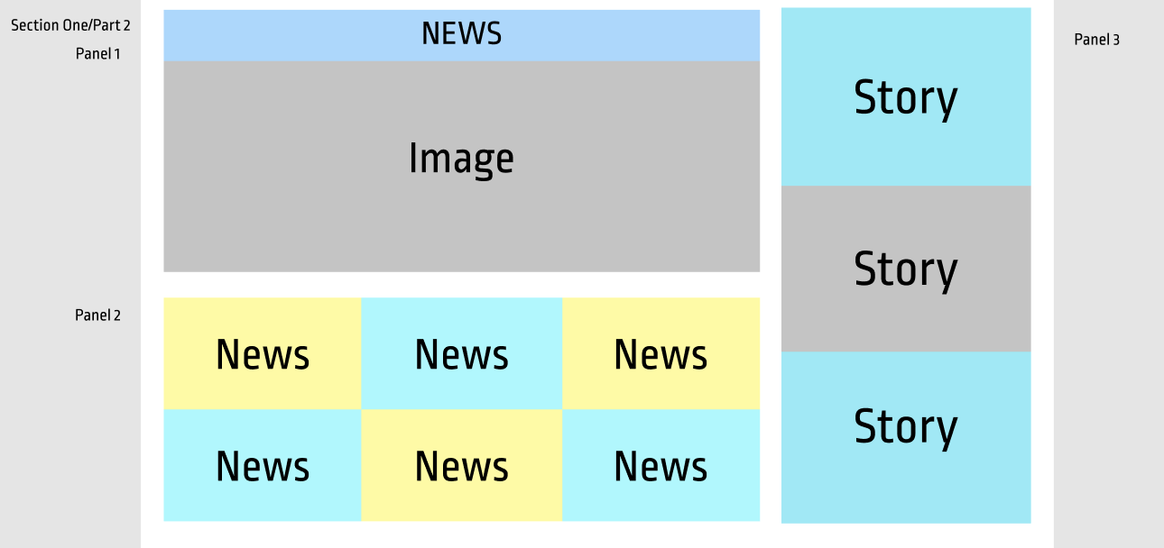

________________________________________________________________

*SECTION 2 (Social Media Feed)*

ARTICLE 3

* Section 2 will contain updated social media posts such Twitter, Instagram, etc.



